# MC MAE BIN LV Monitoring Automation

1. Below SSIS solution which pulls LV data from PPASS for period from last day till today and stores data into OpsBilling.[rprt].[VisitBySourceMCMEABinTermination] table

This job uses below script to pull data from PPBO  
  
  
  
This solution is deployed on DI-BILLING server and runs everyday at 8 AM  
  
1. Next step to run Alteryx job which pulls data from OpsBilling.[rprt].[VisitBySourceMCMEABinTermination] table which filters terminated BINs and return the visit data for period.

Below script used to search for affected BINs



[Gallery](http://10.204.210.202:1433/gallery/#!app/OPS---MC-MEA-BIN-LV-Monitoring/64622f2dc4785cc2c3916745)

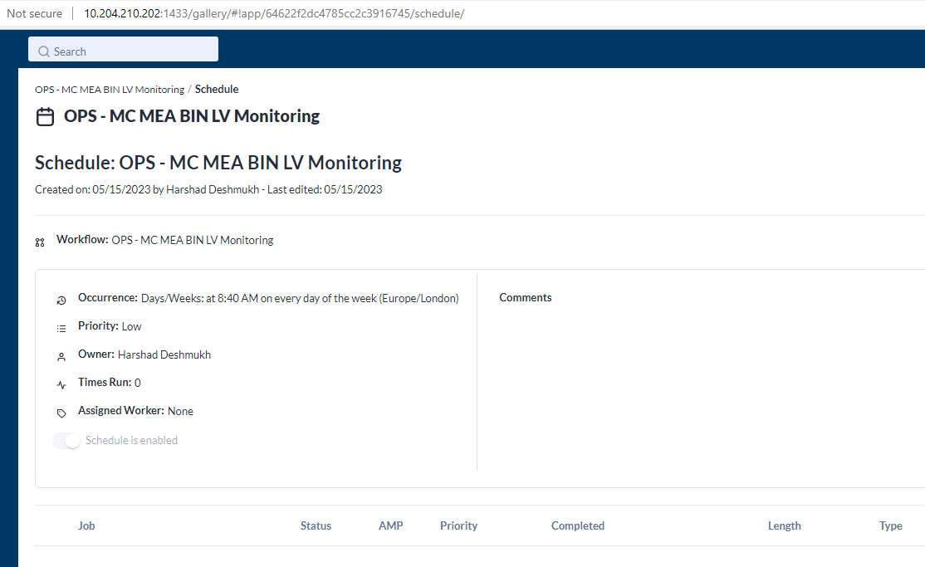  
  
This job runs daily at 8:30 AM which writes data onto below location for MC Team (Callum Francis) As requested this is defined to run till end of June 2023.  
  
\\clbnas01\PriorityPass\5. MasterCard\MC Reports\MEA terminations